Student next assignment submission prediction using machine learning approach

¹Sadiq Hussain, ¹ Mushtaq Hussain, ¹Wenhao Zhu, ¹Muhammad Raza Abidi, ²Sadiq Hussain, ³Zaheer Ullah Khan

¹School of Computer Engineering and Science, Shanghai University, China
²System Administrator,Dibrugarh University, Dibrugarh, Assam, India
³Nanjing University of Aeronautics &Astronautics, China

Read portion is demy value or notes please replace this value with original values

Abstract
The web-based learning platform provides quality education in nowadays, but course next assignment submission is a critical issue in e-learning system. Therefore to detect assignment submission of student in advance before the end, of course, is an important problem. The assignment submission prediction is advantage of e-learning system because it allow the instructor to find students problem on time. This study used machine learning (ML) method to detect students who does not submit assigmetns on time. The data was obtained from open university which is publically avaible. The result show that , ANN is optimal option for predicting student who do not submit assigment on time.

Keywords: Convolution neural network, dropout prediction, feature extraction,

Introduction

The student assignment submission rate affect the student performance in traditional educational as well as e-learning system .
Several studies have been conducted on other problem of e-learning system such student dropout, student performance but there is little research work on student assignment submission prediction.
This result will helpful to instructor to find the reason of student which does not submit assignment on time.
Notes: Please add more details in introduction and conclude introduction on our finding and their benefits

Research questions

Problem Description

In this study, we used student activities data in VLE to predict, is student submit course next assignment
Notes: For problem formulation please read my paper and check their problem formulation portion (Using machine learning to predict student difficulties from learning session data)

Related Work

During the last decade, an increasing number of studies have been making use of educational data for the identification of factors that affect or predict students’ performance. Until recently the approach of these studies employed traditional methods such as regression or covariance analysis.
For example, Ke and Xie [1], applied variations of covariance analysis to quantitative data gathered through surveys to examine the relationship between age and adult students' learning satisfaction, concluding that the evidence suggests there is no correlation. The availability of data, including datasets that are produced through digital measurements, has recently made possible the use of novel, machine learning approaches for their analysis.
For example, Smith et al [2], introduced a deep-learning-based diagrammatic student model, which employs artificial neural networks to analyze student drawings. They predicted student’s understanding and performance. They showed that this model is most accurate and outperforms other competitive baseline diagrammatic student models on both convergence rate and convergence point.
Guo et al [3], developed a Deep Learning classification model which automatically learns multiple levels of representation, to predict student performance. Their experimental results showed the effectiveness of the proposed method which can be applied into academic pre-warning mechanism.
Xiong et al [4], compared the well-studied Performance Factors Analysis (PFA) and Bayesian Knowledge Tracing (BKT) with the emerging Deep Knowledge Tracing (DKT) algorithm in terms of their power of predicting student performance in 5 different data sets. They discovered that when applied to properly prepared datasets, DKT does not clearly outperform PFA.
Wang et al [5], trained a recurrent neural network two tasks of predicting student’s future performance. By training on these tasks, their model exposed patterns about a student’s learning behavior, reliably predicted future student performance, and more interestingly, was able to pick out students who have true knowledge gaps within a pool of poorly performing students.
Okubo et al [6], provided evidence supporting the effectiveness of Recurrent Neural Networks as a method for predicting final grades of students, when compared with multiple regression analysis.
Experimental results provided by Zhao et al [7], showed that a drowsy student state detection method integrating a deep convolutional neural network is more efficient and effective than traditional methods.
Qiu et al [8], showed that a student dropout prediction model based on two-dimensional convolution neural networks (DP-CNN) applied on click stream data of students learning behaviors can achieve better results than the related baseline methods in predicting students’ dropouts in MOOCs.
A deep neural network which is a combination of Convolution Neural Networks (CNN) and Recurrent Neural Networks (RNN), was proposed by Wang, Yu and Miao [9], for the solution of dropout prediction problems in MOOCs. The key advantage of their model is that features used in the model are automatically extracted from the raw records.
Chunqiao, Xiaoning, and Qingyou [10], showed that a neural network model is a reliable tool to predict student study failure risk.
Fok et al [11], focused on how to use Tensorflow artificial intelligence engine for classifying students’ performance and forecasting their future universities degree program. Their results showed that it is not always true that the accuracy of the result increases along with the number of hidden layers of a neural network, but that there is an optimal point.
The potential of machine learning in educational research is also supported by the fact that apart from studies which apply data analysis tools for the derivation of insights concerning students’ performance, other studies aim to develop novel machine learning based tools which can be used in future research.
For example, Ara, Simul, and Islam [12] integrated and develop a student face recognition system using Convolutional Neural Networks (CNN) to generate a low dimensional representation called embeddings, which are used to classify the person’s facial image. Results showed system accuracy greater than 95%. Their face recognition system could be applied for the development of a student attendance system.
In another study, Sun et al [13] employed Convolutional Neural Networks (CNN) to detect emotions by analyzing facial expressions of e-learning students.
AKGÜN et al proposed prediction of elementary teacher candidate of education by using artificial neural networks (ANN) technique to achievements in “Science and Technology Education” courses, and to show the independent variables importance in the prediction, the prediction results show a good specifically for social sciences, also in the prediction of academic performance and achievement [14].
Fumiya Okubo et al used the Recurrent Neural Network technique to predict student’s performance, for final grade by the log data that stored in the educational systems, a dataset contents of 108 student’s, used parameters of RNN that trained by Backpropagation through time, achieve that RNN accuracy is above 90% [15].
BAHADIR proposed two different neural networks used for prediction; in first one used the outcome of mathematics courses, that used as an input for the back-propagation algorithm, the second one uses the scores of all courses, the results show that the back-propagation neural network BPNN model offers comparatively accurate predictions for the student successfully, where an accuracy for the first Neural Network was 77% and for second was 69% in graduate education [16].
CHUNQIAO et al presented a model for forecasting student study through early warning for failure student, based on the TensorFlow platform and Python language used four variables, the result that obtained that the neural network model is a robust and dependable tool to predict student study unsuccessful risk [17].
SMITH et al applied a deep neural network for diagrammatic student models as deep learning, suggests that it can to evaluation and predict student performance, concluded that the deep-learning approach was most accurate and they outperformed this model the other models [18].

Materials and Methods

4.1 Data Description and Study Context
The study used the 400 student data; when they complete the Course assignment in open university. This data is available online for research purposed [ find the reference related to source of data and course check in my research paper (Student engagement prediction in an e-learning system and their impact on student course assessment scores) ]. The period of study are 2017 to 2019. In this study , Data show the student performance, behavior during completing assignments.

Note: please add more details about study context and about course

4.2 Current study Methods
For research ;we applied the following steps, which is shown in Figure 2

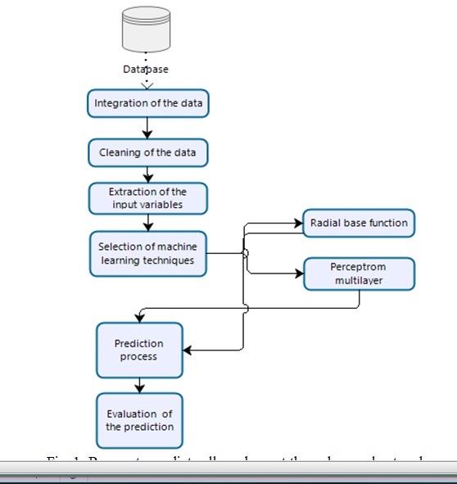

Notes: please build diagram as above in Microsoft viso and put information according to our research paper and put edit version in diagram folder of our github account

4.2.1 Data processing
The data processing steps is important factor of machine learning. in this steps we extract and clean and normalized important features which is important for prediction .In data processing, we converted the data to format which is acceptable for ML, the data processing steps as follows

4.2.1.1 Feature extraction
In feature extraction, we extract the relevant features to predict the next assignment submission.
Note: please give some more details of feature extraction process

4.2.2.2 Data discretization and label assignment
Notes: Please give details of each input variables in form of table in this section

4.1.2 Data and classification technique
Please write some details on every ML Technique which is used this study

5. Experiments and Results
In this paper, we classified the students in two groups, student how submit assignment and other student who do not submit assignment. if the student data can be used to predict to predict group memberships, then e-learning university can customized their feedback for individual perspective student. This is classification problem that is give dataset with free define label. we need to build the model to predict the class of new student. The example using the student data such as students data to predict usage pattern. The target field called assignment submission has two possible values correspond two students groups (assignment submitted , assignment not submitted ).
Our objective to build the classifier using the student data to predict student class and find which features more affect the student class. we used different type of classification algorithms. This section contains following sub portion.

5.1 Data Description and visualization

With help of data visualization, we can try to understand pattern, trend and correlation between the variables. The Figure 1 show that how student who submit and not submit assignment related with student qualification. The Figure 1 show that assignment submission ratio in A level qualified students is high as compare to other students. Mostly the post graduation student does not submit more assignment as compare to other students.
The Figure 2 show relation between student assignments submission state with students age. The result show that, student between the age 0-35 cannot submit more assignment as compare to others students. One possible preseason for that, student in this age are busy in other activities such as collage, university and sport etc.
Figure 3 show the relationships between the target variable and region. The results show that assignment submission rate in East Anglain region is high as compare to other region. The student assignment not submission ration in North and Ireland region is high as compared to other region.
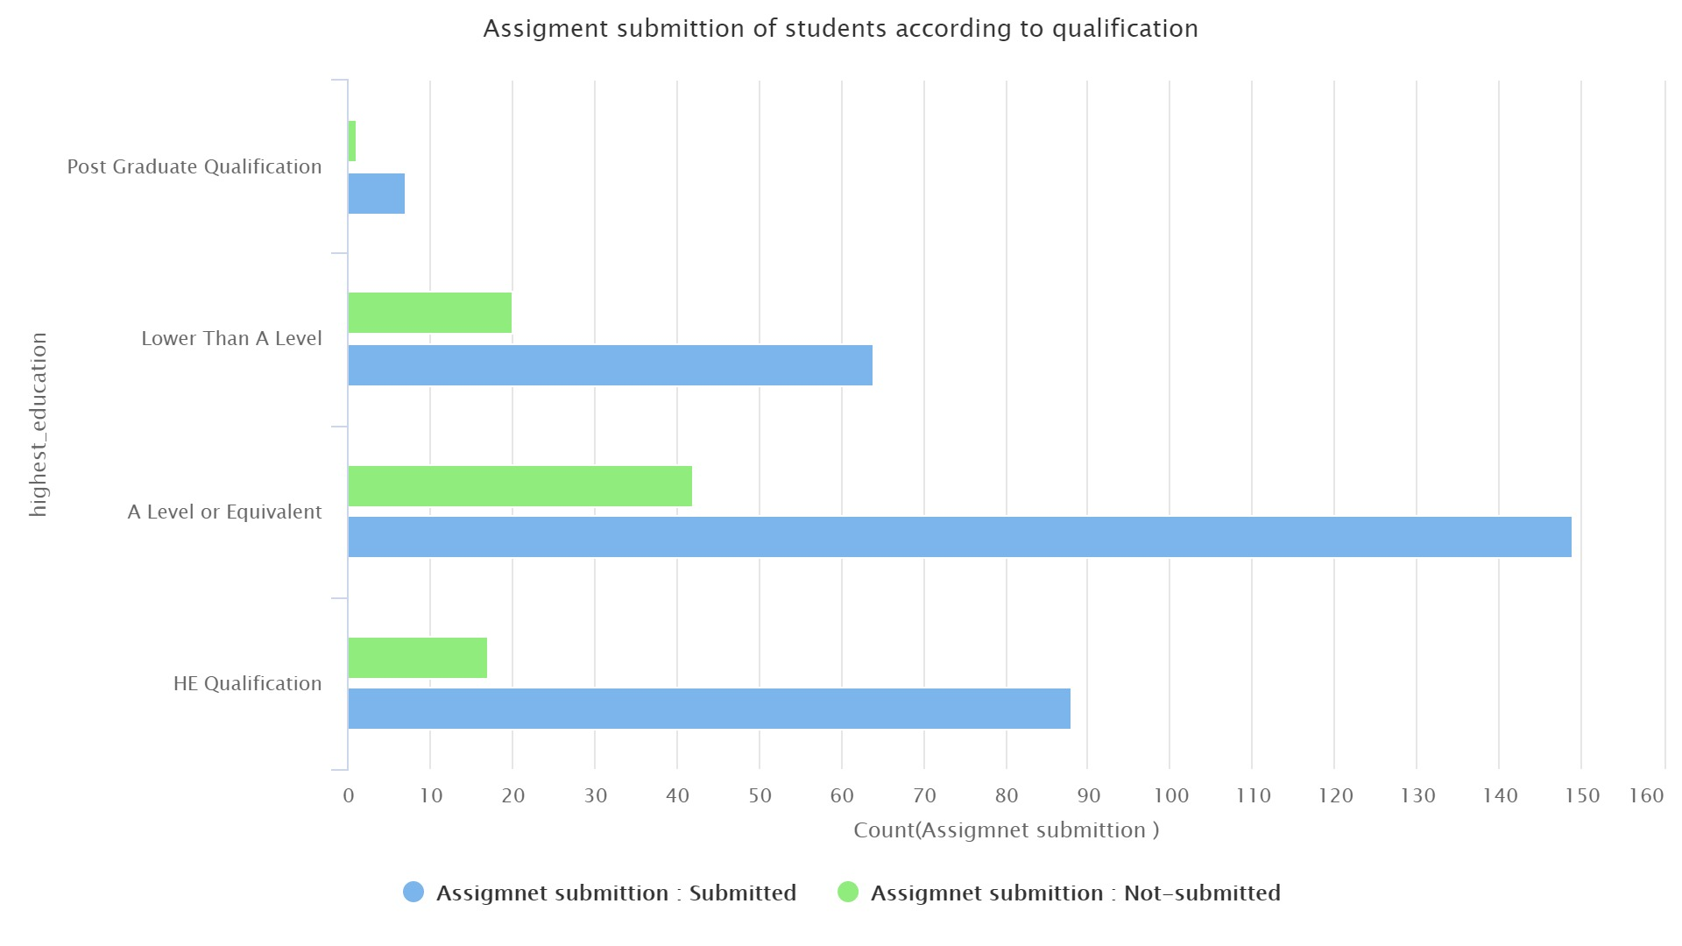
Figure 1. Visualization the students assignment state with students Qualification

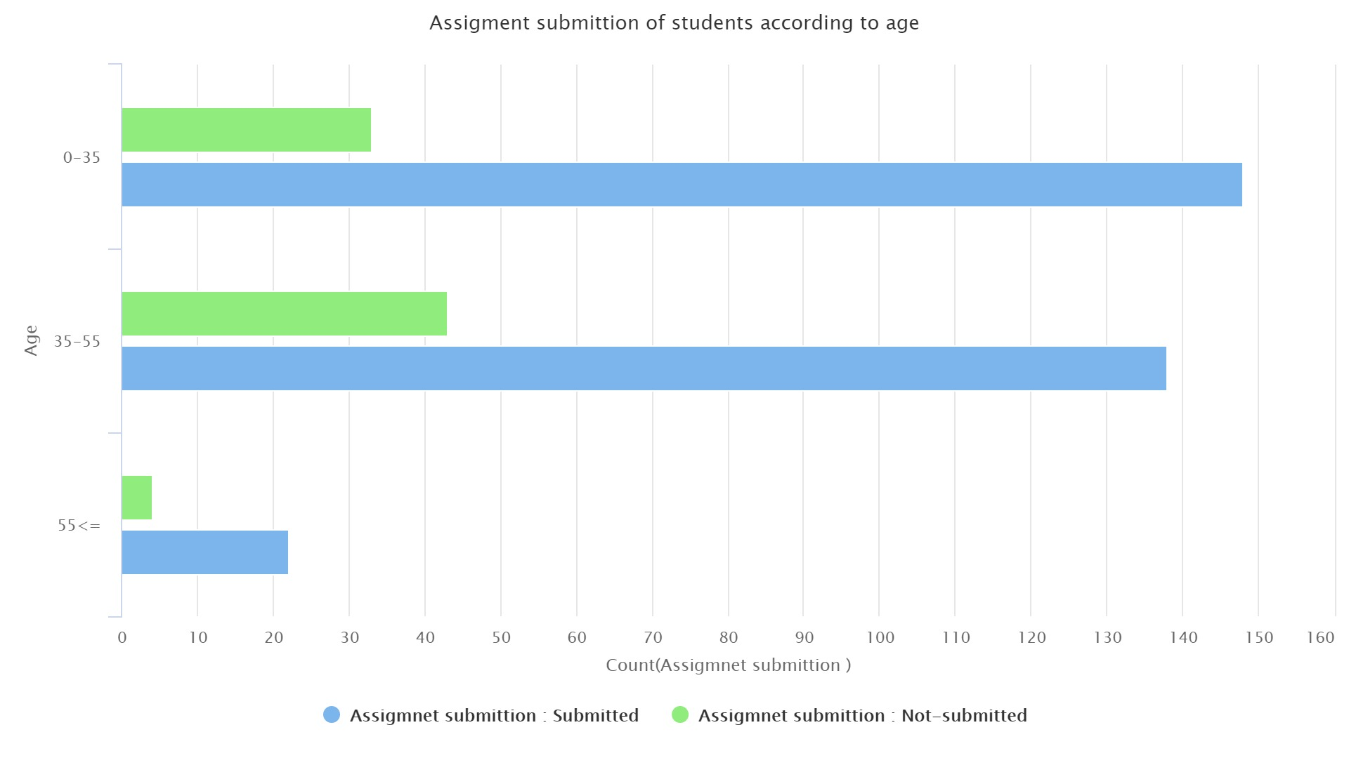
Figure 2. Visualization the students assignment state with students Age

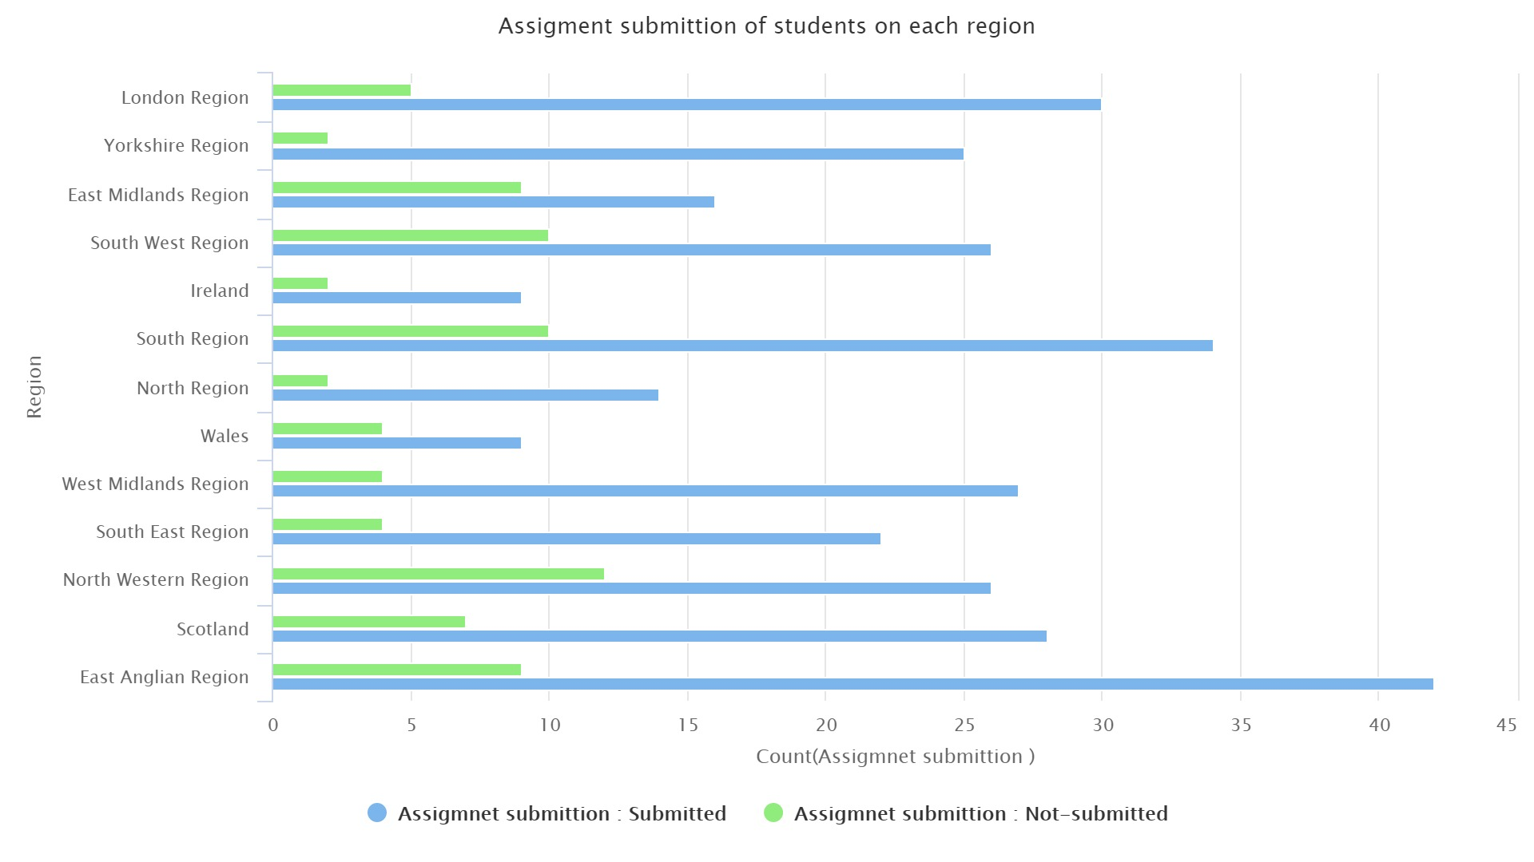
Figure 3. Visualization the students assignment state with students region

5.1 Design of the predictive models and experimental setups
This study used analytical data set of open university. In this study, 460 student enrolled in course. The students complete different assignments during course. The sklearn module of python is used to performed different task such as visualized data describe data and build machine learning models. We tune different parameters of machine learning algorithms to got better results. The input variables of the current study are Student ID', 'final_result','highest_education','Region','disability','studied_credits','score','sum_click'age, region and output variables are submitted or not submitted. we randomly divide the students data into 70% training and 30% testing portion so that it reduced over fitting. we used the first assignment data of student. Some features in our dataset are categorical; therefore we used "LabelEncoder" module of sklearn to covert these features in numeric because some ML algorithms can handle the categorical attributes.
The random forest achieved best performance on the following parameter such as max_depth=3 and n_estimators =10. The logistic regression algorithms setting are random_state=0. The KNN model achieved good accuracy on setting k=1.

5.2 Performance measurements
To select the best ML algorithms for current study, we used accuracy performance parameter and confusion matrix . Accuracy show correctly classified items in test data set. High accuracy indicate that model performance is good in predict student who does not submitted assignment.
Accuracy =TF+TN/TF+FN+FP+TN
Note: True positive (TP); True negative (TN); False Negative (FN); False Positive (FP)

5.3 Results
In this section, we want to find which ML algorithms are suitable to detect students who do not-submit and submit assignment base on student data during course. Next , we want to find which age, region do not submit assignment on time. This will help instructor to customize their feedback and sent mail to those students. We conduct server experiments to get these goals.
To find appropriate classifier to predict student who does not submit assignment during course we build and compare the performance of the following classifiers.
We used training data to train the logistic regression classifier. Then, we test RF classier on test data. The logistic regression received accuracy =0.88. The result are shown in Table 2. There are total 28 students who belong to class "Not-submitted". from out of 28 students , 15 students of class Not-submitted were successfully classified and 13 student were wrongly classified by classifier.

Table 2. Confusion matrix of the RF classifier
Actual | Predicted
 | Not-submitted | Submitted | Class Precision
Not-submitted | TP=15 | FN=13 | 1.0
Submitted | FP=0 | TN=89 | 0.87
Class Recall | 0.70 | 0.93

Next, we trained and test KNN classifier. it obtained 0.78 accuracy. The confusion matrix of KNN classifier are shown in Table 3. The result show that out of 28 not-submitted student, 12 student were successfully classified and 16 student were wrongly classified. On challenging task in KNN classifier are to find the appropriate K value because find the optimal value of K impact the performance of the model. This study try different value of K that is up to 10. We used sklearn module to find appropriate K value which is shown in Figure 7.

Table 3. Confusion matrix of the KNN classifier
Actual | Predicted
 | Not-submitted | Submitted | Class Precision
Not-submitted | TP=12 | FN=16 | 0.57
Submitted | FP=9 | TN=80 | 0.83
Class Recall | 0.43 | 0.90

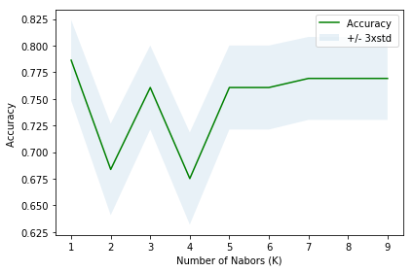

Figure 4. Find appropriate K value for KNN classifiers

Finally we build performance of RF classifier to predict student who do not complete assignment on time. RF classifier receive high accuracy =0.93 using student data and correctly predict 20 student from out 28 student who do not submit assignment.

Table 4. Confusion matrix of the RF classifier
Actual | Predicted
 | Not-submitted | Submitted | Class Precision
Not-submitted | TP=20 | FN=8 | 1
Submitted | FP=0 | TN=89 | 0.92
Class Recall | 0.71 | 1

AS the result show that RF classifier predict the student who does no submit assignment with high accuracy as compared to the other model of the study; therefore visualized the RF classifier decision tree which is shown in Figure 8.

5.4 Discussion

There are two main goal of this study , First find the appropriate ML model which predict not submitted assignment students with high accuracy and second find which input features greatly affect the classifier. In machine learning, the performance of learning models depend on classification data. The results show that performance of decision tree model ( RF classifier) predict not-submitted assignment class with high accuracy because DT classifiers is appropriate for categorical data as compared to other model of this study. Furthermore , DT classifier split the difficult task in simple classification task and using bagging feature to predict the not-submitted student with high accuracy.
The performance of KNN and logistic regression is not good as compare to RF classifiers. On possible reason is that, KNN need appropriate K value which is challenging tasks for the researcher and also affect the performance of models.
In order to find how the student input features are relate to student assignment state. we plot tree using RF classifiers which shown in Figure 5. We got some important results during plot the decision tree using RF which is interpreted as follow.
The Figure show that students Gender, Student ID, Student Credit, Final result , Total clicks, Score play important role in predicting the student who do not submit assignment during course because the features are shown many time in decision tree. Others input variables are not shown in plot which indicate that these variables are not important for model prediction.
The graph show that Total click is important predictor of this study because number clicks show engagement of student in solving the exercise , greater the number clicks they have greater chance to submit the assignments . Furthermore , the graph show that high score student mostly greater chance to submit assignment as compare to low score students.

Figure 5: Plot the decision tree using RF classifier

Conclusions and Future Work

6.1 Limitation and Future work

Data Availability
The current study data are publicly available online (https://archive.ics.uci.edu/ml/datasets/Educational+Process+Mining+%28EPM%29%3A+A+Learning+Analytics+Data+Set) for research purposes. Ethical clearance was granted by the University of Genoa, Italy. No personal information (e.g., name or address) of the participants was included in this study.
Conflicts of Interest
The authors have no conflicts of interest
Funding Statement
References
[1] Ke, F., & Xie, K. (2009). Toward deep learning for adult students in online courses. The Internet and Higher Education, 12(3-4), 136-145. doi:10.1016/j.iheduc.2009.08.001
[2] Smith, A., Min, W., Mott, B. W., & Lester, J. C. (2015). Diagrammatic Student Models: Modeling Student Drawing Performance with Deep Learning. Lecture Notes in Computer Science, 216-227. doi:10.1007/978-3-319-20267-9_18
[3] Guo, B., Zhang, R., Xu, G., Shi, C., & Yang, L. (2015). Predicting Students Performance in Educational Data Mining. 2015 International Symposium on Educational Technology (ISET). doi:10.1109/iset.2015.33
[4] Xiong, X., Zhao, S., Inwegen, E.V., & Beck, J.E. (2016). Going Deeper with Deep Knowledge Tracing. EDM.
[5] Wang, L., Sy, A., Liu, L., & Piech, C. (2017). Deep Knowledge Tracing On Programming Exercises. Proceedings of the Fourth (2017) ACM Conference on Learning @ Scale - L@S '17. doi:10.1145/3051457.3053985
[6] Okubo, F., Yamashita, T., Shimada, A., & Ogata, H. (2017). A neural network approach for students' performance prediction. Proceedings of the Seventh International Learning Analytics & Knowledge Conference on - LAK '17. doi:10.1145/3027385.3029479
[7] Zhao, G., Liu, S., Wang, Q., Hu, T., Chen, Y., Lin, L., & Zhao, D. (2018). Deep convolutional neural network for drowsy student state detection. Concurrency and Computation: Practice and Experience, 30(23), e4457. doi:10.1002/cpe.4457
[8] Qiu, L., Liu, Y., Hu, Q., & Liu, Y. (2018). Student dropout prediction in massive open online courses by convolutional neural networks. Soft Computing. doi:10.1007/s00500-018-3581-3
[9] Wang, W., Yu, H., & Miao, C. (2017). Deep Model for Dropout Prediction in MOOCs. Proceedings of the 2nd International Conference on Crowd Science and Engineering - ICCSE'17. doi:10.1145/3126973.3126990
[10] Chunqiao, M., Xiaoning, P., & Qingyou, D. (2018). An Artificial Neural Network Approach to Student Study Failure Risk Early Warning Prediction Based on TensorFlow. Lecture Notes of the Institute for Computer Sciences, Social Informatics and Telecommunications Engineering, 326-333. doi:10.1007/978-3-319-73317-3_38
[11] Fok, W. W., He, Y., Yeung, H. A., Law, K., Cheung, K., Ai, Y., & Ho, P. (2018). Prediction model for students' future development by deep learning and tensorflow artificial intelligence engine. 2018 4th International Conference on Information Management (ICIM). doi:10.1109/infoman.2018.8392818
[12] Ara, N. M., Simul, N. S., & Islam, M. S. (2017). Convolutional neural network approach for vision based student recognition system. 2017 20th International Conference of Computer and Information Technology (ICCIT). doi:10.1109/iccitechn.2017.8281789
[13] Sun, A., Li, Y., Huang, Y., & Li, Q. (2017). Using Facial Expression to Detect Emotion in E-learning System: A Deep Learning Method. Emerging Technologies for Education, 446-455. doi:10.1007/978-3-319-71084-6_52
[14] AKGÜN, Ergün; DEMIR, Metin. Modeling Course Achievements of Elementary Education Teacher Candidates with Artificial Neural Networks. Online Submission, 2018, 5.3: 491-509.
[15] Fumiya Okubo, Takayoshi Yamashita, Atsushi Shimada, Hiroaki Ogata, A Neural Network Approach for Students’ Performance Prediction, LAK 2017, pp.598-599, 2017.3.
[16] FOK, Wilton WT, et al. Prediction model for students' future development by deep learning and tensorflow artificial intelligence engine. In: 2018 4th International Conference on Information Management (ICIM). IEEE, 2018. p. 103-106.‏
[17] CHUNQIAO, Mi; XIAONING, Peng; QINGYOU, Deng. An artificial neural network approach to student study failure risk early warning prediction based on TensorFlow. In: International Conference on Advanced Hybrid Information Processing. Springer, Cham, 2017. p. 326-333.‏
[18] SMITH, Andy, et al. Diagrammatic student models: Modeling student drawing performance with deep learning. In: international Conference on User modeling, adaptation, and Personalization. Springer, Cham, 2015. p. 216-227.‏

Impact of Different Data Types on Classifier Performance of Random Forest, Naïve Bayes, and K-Nearest Neighbors Algorithms

